Draft for Initial Discussion

UN ICT4SIDS Partnership (www.ict4sids.com)

Invitation to Launch Smart Hubs for Rapid Implementation of SDGs in (Country)

This is an invitation to launch a Free Pilot Project that will focus on Smart Hubs for rapid implementation of SDGs. This 3 months Project is based on the following phases shown in Figure1.
Suggestion to the User: Please visit the ICT4SIDS site (www.ict4sids.com), especially the Getting Started section for general information about the UN ICT4SIDS Partnership.
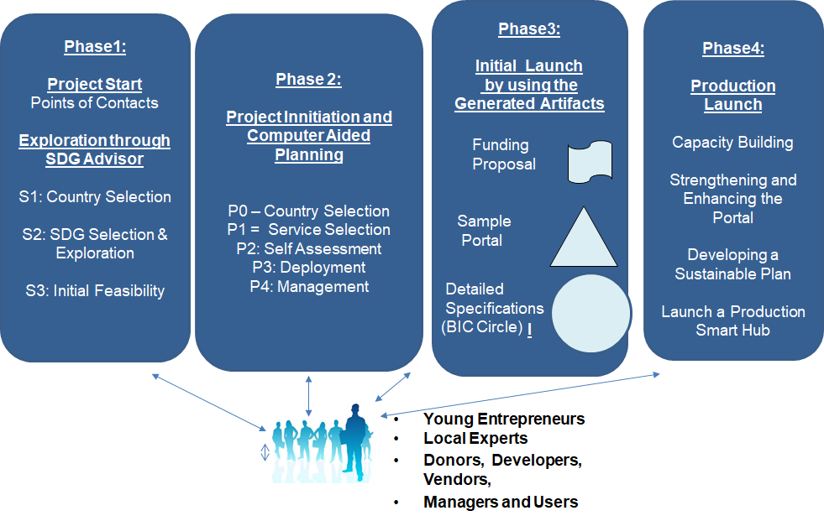
Figure1: Pilot Project Methodology

PHASE1: Computer Aided Feasibility Study (Conducted by using the SDG Advisor)
A Pilot Project is initiated by a User (e.g., SIDS, LDC or any other) by sending an email to Dr Umar at umar@amjadumar.com (Subject: Smart Hub Pilot Project), explaining the main objective of the Pilot Project.
- The pilot project is limited to a maximum of 3 single service hubs or a community center with 3-4 services. Duration is 3 months, after Kickoff, at no cost (no money exchanges hands).
- Points of Contact (POC) are appointed for the Project from the User as well as ICT4SIDS side after some email exchanges and possibly phone/skype chats to clarify the goals and expectations.
- We request that the customer visit the ICT4SIDS Partnership site at www.ict4sids.com site and familiarize him/herself with the basic capabilities, especially the SDG Advisor, of the site by viewing videoclips and reviewing the basic documents posted on the learning corner.
- We will initiate the pilot project on an agreed upon Kickoff date by sending the User POC a rough plan of action and Free Login ID-PW so that the User can start using the SDG Advisor.

Phase 1 of our methodology conducts a quick feasibility study by asking the following questions and then helps a user to select and launch low cost but high impact pilot projects:
- What is the objective of the proposed pilot project?
- What is the status of my country/region (good/bad) for SDGs of interest?
- What type of services could improve the needed status?
- What are the costs versus benefits of launching a service and which services are low cost but high benefit within the local context?

Phase1 typically concludes in 1-2 weeks after Kickoff. The POCs (SIDS and ICT4SIDS) fill out the information shown in Table1 (about 12 questions) and sign this form to launch agreed upon Smart Hubs for the Pilot Project.

PHASE2 (Computer Aided Planning and Hub Generation)
- The Computer Aided Planning, initially conducted by the ICT4SIDS staff, can be completed within a day and produces an executive summary, a funding proposal and a working prototype of the selected Hub(s) as shown in Figure 1
- After the first Planning run, the POC is given some training so that POC may use the SPACE Planning Toolkit to generate own hubs.

PHASE 3 and 4:
- Familiarization: The Customer POC reviews the outputs produced by SPACE. The POCs, and other invited individuals, conduct a detailed walkthrough of the outputs produced by SPACE and determine what can be used quickly
- Initial Portal Launch: The Demo Portal is modified to provide initial services that can be offered to the users (e.g., training materials, mobile apps, basic advisory services, etc).
- Extensions and Use: The Demo Portal is converted into an operational portal through several refinements and extensions based on the user feedback.
- Project Conclusion (2-3 months after Project Start):
- Identification of funding and partnership opportunities
- Development of a detailed plan for future deployments and expansions
- Development of a short (2 page) case study that describes project objectives, key players and the results obtained.

TEAM FORMATION AND KEY QUESTIONS TO GET STARTED (based on initial Discussion)
Suggestion: Please fill out the form below and highlighted areas

ICT4SIDS Team:
- Amjad Umar (ICT4SIDS POC): email= umar@amjadumar.com, Phone = 717-901-5141
- Customer Support (Arslan Dawood), email: advong@gmail.com
- Technical Support (Hannan Dawood): email: Hannan@ngesolution.com
- Pilot Project Manager (TBD): email:
- Additional Team Members Needed: TBD

User Team for Island or Country: _______________
- ICT4SIDS Regional Representative: __________________
- Main User POC (Name, email, Phone): __________________________
- Additional Members, if any (Name, email, Phone): _______________

Table1: KEY QUESTIONS TO GET STARTED

Suggested Project Kickoff Date = _____??___
Suggested Project Conclusion Date = _____??___
Country/Region Specification: What is the region/country involved ________________

Overall Goals and Service Specification | Hub Sector and Service (SDG Goal)
- What is the goal of the Pilot Project and what are the main expected results (Suggestion: please write a brief Concept Note in Exhibit2 to provide any additional background information)
- What is the name of a sector your Hubs will focus on (e.g., health, education, public safety, public welfare, etc) and/or the SDG Goals of interest (e.g., 1, 2, 3,,,17)
- What are the names of the 3-4 service you are interested in (e.g., telemedicine, educating school teachers, disaster management, etc) – Please select From Exhibit1 (or enter a new one)
- Is this Hub virtual (website), physical or both
- Is this Hub for Urban or Rural areas
- How many users will be served (typically 5000-10,000) .
- Will it operate at a Local, State (Regional) or National level.
- Will the service be mainly information dissemination (e.g., guidance, advice) or transactional (e.g., online purchasing)
P2 (Self Assessment):
- What are the major benefits (e.g., public service).
- What are the major costs: Low (under 5K) or high (10K USD or higher).
- Do the users need to be trained for maximum benefits.
- Do you need trained staff to manage this Hub
- What are possible sources of funding.

Other Observations (based on initial email exchanges and a Skype Chat):
_____________________________________________________________________________
___________________________________________________________________________________

Signed and Dated (ICT4SIDS POC):

Signed and Dated (User Point of Contact):

Exhibit 1: Sample SPACE Services

SPACE supports almost 100 services in sectors such as economic development, education, healthcare and others (see the table below). In addition, the ICT infrastructure is a horizontal sector that supports all vertical sectors. These services can also be combined into “Service Bundles” that represent inter and intra enterprise composites such as villages, communities, cities and B2B marketplaces.
This is a very powerful capability that can be used to build models of a large number of configurations in public and private sectors.

Economic Development | Education | Healthcare | Law Enforcement & Safety | Transportation & Agriculture | Public Welfare & Environment Services | Common  Services
Entrepreneurship  Micro-Entrepreneurship  Micro-Financing Information Systems  e-Employment  e-Tourism  e-Library (public) | Educating Primary School Teachers  e-learning for the handicapped  e-Learning Support System  e-Library (school) | Mobile Health Clinic  Electronic Health Records  Emergency Medical Service  m-Health (General)  Hospital Information System  Patient Information System  Decision Support for Health  Telemedicine  e-Behaviourial Health | Police & Fire Services  Police Crime Investigation Services  Social Network Services for Governments  Additional Law and Order Services  Weather Alert and Travel Warning  Food Quality and Drinking Water Purity  Disaster Management and Recovery | Optimal Route Planner  Alert Systems  Automobile Licensing  e-Agriculture 2.0  E-Agriculture Phone2SMS  Eservices for Food Safety  Precision Agriculture  eServices for Agriculture | Social Services  Citizen Welfare Services  Public Healthcare Service  eLearning for Needy Children  Assisted Living  eCare for Aging Populations  Entrepreneurship Welfare Programs  Clean Air  Environmental Monitoring  Environmental Analytics | Corporate Management Services  Customer Services  Marketing Services  Sales Services  e-Payment  EFT – Electronic Fund Transfer  Credit Card Detection System  e-Banking System
ICT Infrastructure Services (Horizontal)
- Broadband Access, Network Management, Social Networking (*e-Participation, e-Voting), Cloud Computing
Enterprise-Wide Service Composite (Service Bundles that Combine Many Individual Services)
- Offices, Departments, Initiatives (e.g., MDG, Mobility, Telemedicine, Aging Population) Services, Firms, Business Units, eCities, eCommunities, Government Specific Initiatives
Inter-Enterprise Service Composites (Service Bundles for B2B and G2G Integrations)
- G2G Services (Interagency Exchanges), Supply Chain for Food Distribution, Health informational Networks, Educational Networks, Entrepreneurial Networks, B2G Services
.

Exhibit 1: Short Concept Note (Strongly Suggested)

Note: This brief concept note (one page) provides background information and identifies the key drivers for launching the Pilot Project.

